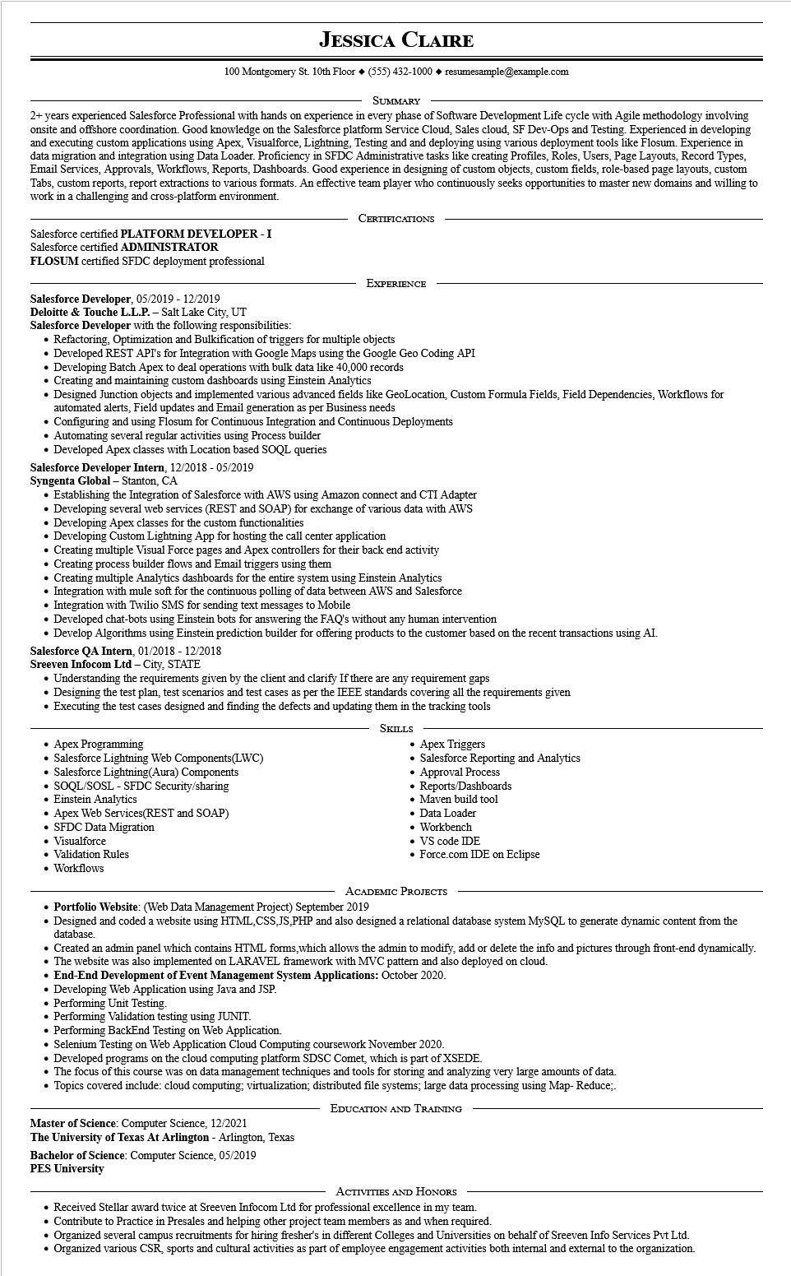
JESSICA CLAIRE
100 Montgomery St. 10th Floor (555) 432-1000 resumesample@example.com
SUMMARY
2+ years experienced Salesforce Professional with hands on experience in every phase of Software Development Life cycle with Agile methodology involving onsite and offshore coordination. Good knowledge on the Salesforce platform Service Cloud, Sales cloud, SF Dev-Ops and Testing. Experienced in developing and executing custom applications using Apex, Visualforce, Lightning, Testing and and deploying using various deployment tools like Flosum. Experience in data migration and integration using Data Loader. Proficiency in SFDC Administrative tasks like creating Profiles, Roles, Users, Page Layouts, Record Types, Email Services, Approvals, Workflows, Reports, Dashboards. Good experience in designing of custom objects, custom fields, role-based page layouts, custom Tabs, custom reports, report extractions to various formats. An effective team player who continuously seeks opportunities to master new domains and willing to work in a challenging and cross-platform environment.
Salesforce certified PLATFORM DEVELOPER - I Salesforce certified ADMINISTRATOR
FLOSUM certified SFDC deployment professional
Salesforce Developer, 05/2019 - 12/2019
Deloitte & Touche L.L.P. - Salt Lake City, UT
CERTIFICATIONS
EXPERIENCE
Salesforce Developer with the following responsibilities:
Refactoring, Optimization and Bulkification of triggers for multiple objects
Developed REST API's for Integration with Google Maps using the Google Geo Coding API
Developing Batch Apex to deal operations with bulk data like 40,000 records
Creating and maintaining custom dashboards using Einstein Analytics
• Designed Junction objects and implemented various advanced fields like GeoLocation, Custom Formula Fields, Field Dependencies, Workflows for automated alerts, Field updates and Email generation per Business needs
Configuring and using Flosum for Continuous Integration and Continuous Deployments
• Automating several regular activities using Process builder
• Developed Apex classes with Location based SOQL queries
Salesforce Developer Intern, 12/2018 - 05/2019
Syngenta Global - Stanton, CA
Establishing the Integration of Salesforce with AWS using Amazon connect and CTI Adapter
• Developing several web services (REST and SOAP) for exchange of various data with AWS Developing Apex classes for the custom functionalities
Developing Custom Lightning App for hosting the call center application
Creating multiple Visual Force pages and Apex controllers for their back end activity
• Creating process builder flows and Email triggers using them
Creating multiple Analytics dashboards for the entire system using Einstein Analytics
• Integration with mule soft for the continuous polling of data between AWS and Salesforce
• Integration with Twilio SMS for sending text messages to Mobile
Developed chat-bots using Einstein bots for answering the FAQ's without any human intervention
• Develop Algorithms using Einstein prediction builder for offering products to the customer based on the recent transactions using AI. Salesforce QA Intern, 01/2018 - 12/2018
Sreeven Infocom Ltd - City, STATE
Understanding the requirements given by the client and clarify If there are any requirement gaps
• Designing the test plan, test scenarios and test cases as per the IEEE standards covering all the requirements given
• Executing the test cases designed and finding the defects and updating them in the tracking tools
• Apex Programming
• Salesforce Lightning Web Components(LWC)
• Salesforce Lightning(Aura) Components
• SOQL/SOSL-SFDC Security/sharing
Einstein Analytics
Apex Web Services(REST and SOAP)
SFDC Data Migration
Visualforce
Validation Rules
• Workflows
SKILLS
• Apex Triggers
• Salesforce Reporting and Analytics Approval Process
• Reports/Dashboards
• Maven build tool
• Data Loader
• Workbench
VS code IDE
• Force.com IDE on Eclipse
ACADEMIC PROJECTS
• Portfolio Website: (Web Data Management Project) September 2019
Designed and coded a website using HTML, CSS, JS,PHP and also designed a relational database system MySQL to generate dynamic content from the database.
Created an admin panel which contains HTML forms, which allows the admin to modify, add or delete the info and pictures through front-end dynamically. The website was also implemented on LARAVEL framework with MVC pattern and also deployed on cloud.
End-End Development of Event Management System Applications: October 2020.
• Developing Web Application using Java and JSP.
Performing Unit Testing.
Performing Validation testing using JUNIT.
Performing BackEnd Testing on Web Application.
Selenium Testing on Web Application Cloud Computing coursework November 2020.
Developed programs on the cloud computing platform SDSC Comet, which is part of XSEDE.
• The focus of this course was on data management techniques and tools for storing and analyzing very large amounts of data.
Topics covered include: cloud computing; virtualization; distributed file systems; large data processing using Map- Reduce;.
Master of Science: Computer Science, 12/2021
The University of Texas At Arlington - Arlington, Texas
Bachelor of Science: Computer Science, 05/2019
EDUCATION AND TRAINING
PES University
ACTIVITIES AND HONORS
Received Stellar award twice at Sreeven Infocom Ltd for professional excellence in my team. Contribute to Practice in Presales and helping other project team members as and when required.
Organized several campus recruitments for hiring fresher's in different Colleges and Universities on behalf of Sreeven Info Services Pvt Ltd. • Organized various CSR, sports and cultural activities as part of employee engagement activities both internal and external to the organization.

